**Session-13 Assignment**

**Name:-** Aryan Dilipbhai Langhanoja

**Enroll No:-** 92200133030

**AIM**: To understand various biasing techniques of transistor.

**Apparatus:**

1. Function generator
2. Dc power supply
3. Switch
4. Transistor (BC547)
5. Capacitor
6. Resistors
7. Oscilloscope

**Task-1- Emitter Biasing / Emitter Feedback Bias**

**Sample Circuit diagram:**



**Write equations of base-emitter loop and collector-emitter loop and** **get the values of IB,IC,VCE,VC,VE,VB,VBC**

**IB = (**VCC - VBE) / RB + (β + 1) RE = 40.12 µA

**IC =** βIB = 2.006 mA

**VCE** = VCC – (RC + RE) IC (Assuming IC≈IE) = 13.982 V

**VC** = VCC - ICRC = 17.994 V

**VE** = VCC – IBRB - VBE = 2.0484 V

**VB** = VCC - IBRB = 2.7484 V

**VBC**= ICRC - IBRB = - 15.2456 V

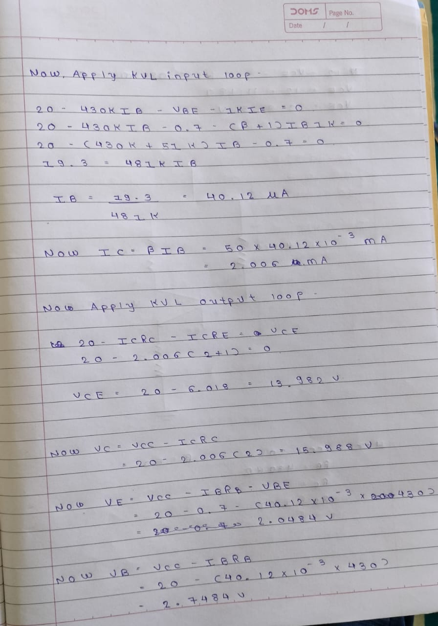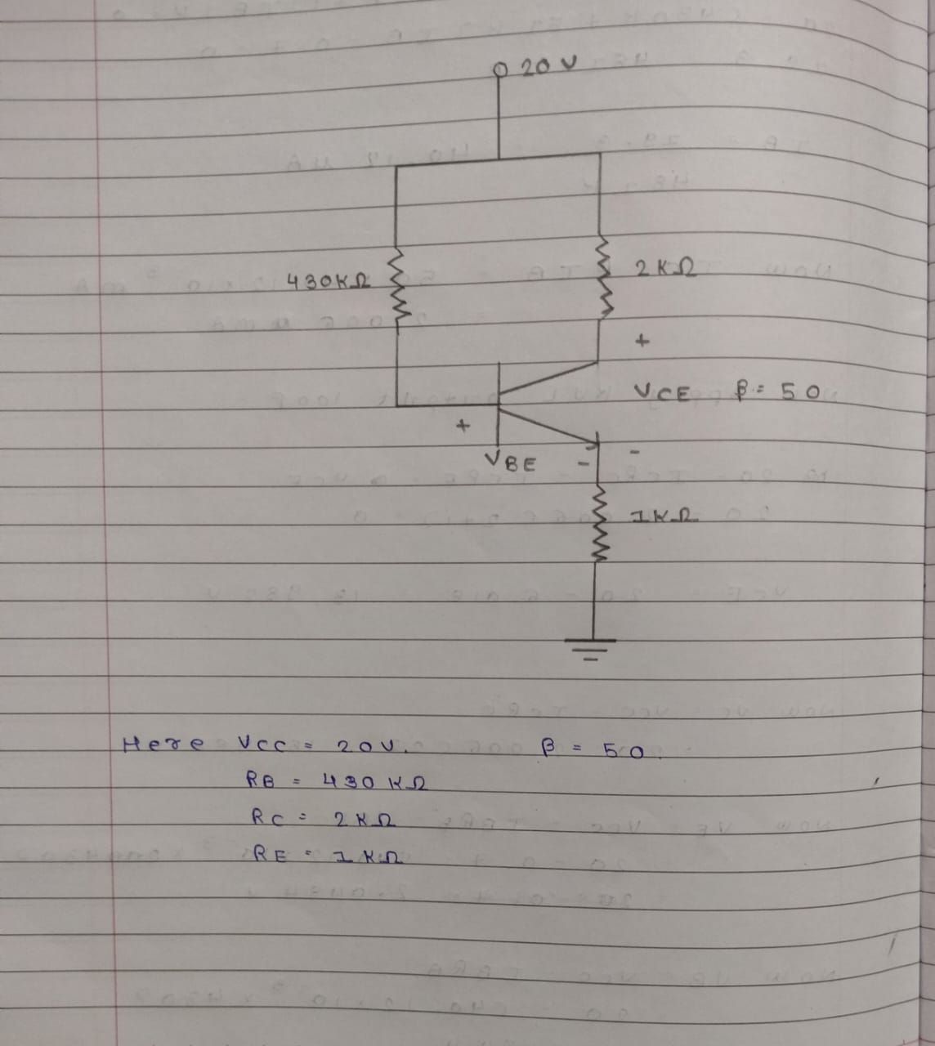

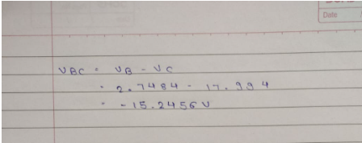

**Multisim Circuit:-**

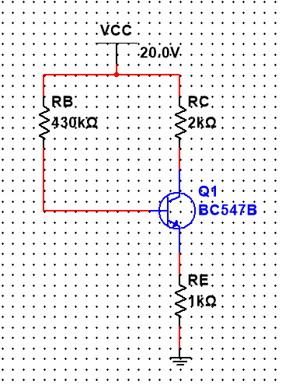

**Task-2- Collector Feedback Bias without emitter resistor**

**Sample Circuit diagram:**

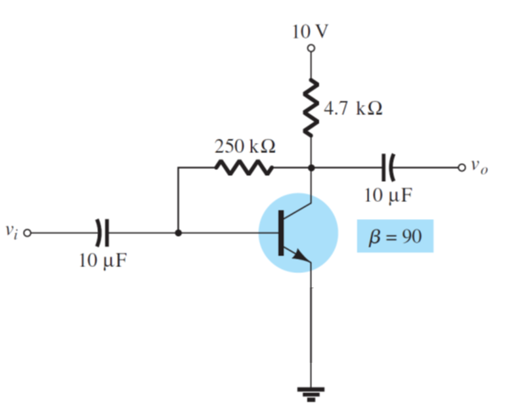

**Write equations of base-emitter loop and collector-emitter loop** **and get the values of IB,IC,VCE**

**IB =** (VCC – VBE)/ (RC (β + 1) + RB)

= 17.73 µA

**IC** = βIB. = 1.2357 mA

**VCE** = VCC – RC(IC + IB). = 4.128 V

**Multisim Circuit:**

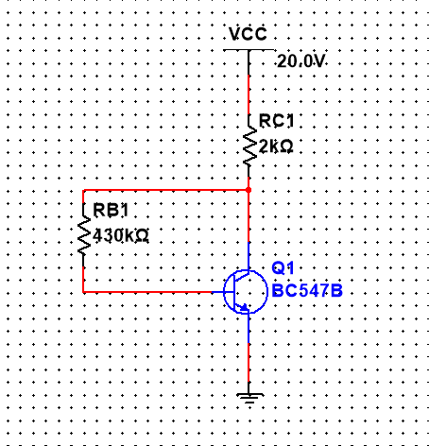

**Task-3- Collector Feedback Bias with emitter resistor**

**Sample Circuit diagram:**



**Write equations of base-emitter loop and collector-emitter loop and get the values of IB,IC,VCE**

**IB** = (VCC – VBE) / (β + 1) (RC + RE) +RB

= 11.81 µA

**IC** = βIB = 1.063 mA

**VCE** = VCC - ((β + 1) IB)(RC + RE) = 3.66 V

**Multisim Circuit:**

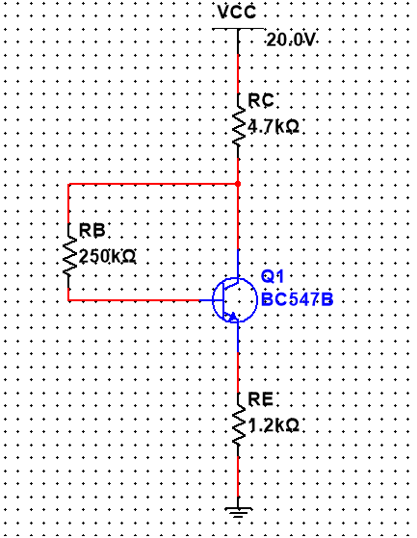

**Conclusion:**